Algorithm
Pdf – 1
1. What is Algorithm?
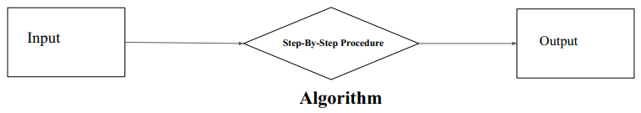
Ans: An algorithm is a step-by-step procedure or a set of instructions designed to perform a specific task or solve a particular problem.

2. What is the need for algorithms?
1.Efficiency: Algorithms help in solving problems in an efficient manner.
2.Problem-Solving: Algorithms are a framework for solving problems systematically.
3.Scalability: Well-designed algorithms allow systems to handle increasing loads of data.
4.Standardization: Algorithms provide a standardized way to solve specific types of problems.
5.Optimization of Costs: Algorithms help achieve these goals through optimization techniques.
6.Complex Problem Solving: Some problems, especially in fields like cryptography, optimization, and artificial intelligence, are highly complex and require sophisticated algorithms to be solved.

3. What are the Criteria for an algorithm?
1.Input: Zero or more quantities are externally supplied.
2.Output: At least one quantity is produced.
3.Definiteness: Each instruction is clear.
4.Finiteness: The algorithm terminates after a finite number of steps.
5.Effectiveness: Every instruction must be basic and feasible.

4. Advantages of Algorithms.
1. Easy to Understand
2. Step-by-Step Representation
3. Simplifies Complex Problems
4. Language Independence
5. Easy to Debug and Test
6. Improves Efficiency & Accuracy
7. Optimization

5. What is Complexity Analysis? Why it needs?
Complexity analysis evaluates the efficiency of an algorithm based on its resource consumption.
Why it needs:
1.Ensures efficient resource usage.
2.Helps in comparing algorithms.
3.Critical for scalability with large inputs.

6. Work on Best, Worst and Average Cases.
Best-case: Minimum time for most favorable input.
Worst-case: Maximum time for the least favorable input.
Average-case: Expected time for random inputs.

Pdf – 2
7. Big Oh, O: Asymptotic Upper Bound.
A function f(n) can be represented is the order of g(n) that is O(g(n)), if there exists a value of positive integer n as n0 and a positive constant c such that –
f(n)⩽c.g (n) for n>n0 in all case
Hence, function g(n) is an upper bound for function f(n), as g(n) grows faster than f(n).

8. (11-14) page Find Time and Space Complexity.

Pdf – 4
9. Bubble Sort:
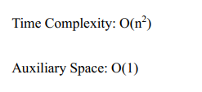
i. Explain Bubble sort with Algorithm Step.
Answer: Hand practices bubble sort.
Algorithm Steps:
1. Start from the first element.
2. Compare the current element with the next element.
3. If the current element is greater than the next element, swap them.
4. Move to the next element and repeat step 2 and 3.
5. Repeat the process for the entire list until no swaps are needed.

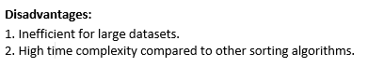
ii. Advantages and Disadvantages of Bubble sort.
Advantages:
1. Bubble sort is easy to understand and implement.
2. It does not require any additional memory space.
3. It is a stable sorting algorithm

10. Explain Divide and conquer Algorithm with diagram.
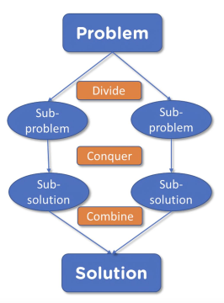
Divide-and-conquer recursively solves subproblems. each subproblem must be smaller than the original problem, and each must have a base case. A divide-and-conquer algorithm has three parts:
● Divide up the problem into a lot of smaller pieces of the same problem.
● Conquer the subproblems by recursively solving them. Solve the subproblems as
base cases if they're small enough.
● To find the solutions to the original problem, combine the solutions of the subproblems.

11. Merge Sort:
i. Explain Merge sort with Algorithm step.
Ans: Hand practices Merge sort.
Algorithm Step:
Step 1: Divide: The primary step is to repeatedly divide the input list into two halves until you reach sub lists containing
only one element.
Step 2: Conquer (Merge): After dividing, the algorithm starts merging the single-element lists back together in sorted order.
Step 3: Combine: The merging process continues until all the sub lists are merged into one single sorted list.

ii. Advantages and Disadvantages of Merge Sort.
Advantages:
1.Merge sort is a stable sorting algorithm, which means it maintains the relative order of equal elements in the input array.
2.Merge sort has a worst-case time complexity of O(N logN) , which means it performs well even on large datasets.
3.The divide-and-conquer approach is straightforward.

Disadvantages:
1. Merge sort requires additional memory to store the merged sub-arrays during the sorting process.
2. Not Merge sort is not an in-place sorting algorithm, which means it requires additional memory to
store the sorted data.
3. Merge Sort is Slower than Quick Sort.

12. Quick Sort:
i. Explain Quick Sort with Algorithm step.
Ans: Hand practices quick sort.
Algorithm Step:
Step1: Choose the pivot (usually first or last element).
Step2: Set left pointer at low, right pointer at high.
Step3: While left ≤ right:
i. Move left right while arr[left] < pivot
ii. Move right left while arr[right] > pivot
iii. If left < right, swap arr[left] and arr[right].
iv. Otherwise, return the right pointer as the partition index.

ii. Advantages and Disadvantages of Quick Sort.
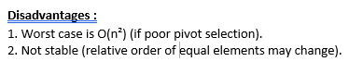
Advantages:
1. It is a divide-and-conquer algorithm that makes it easier to
solve problems.
2. It is efficient on large data sets.
3. It has a low overhead, as it only requires a small amount of
memory to function.

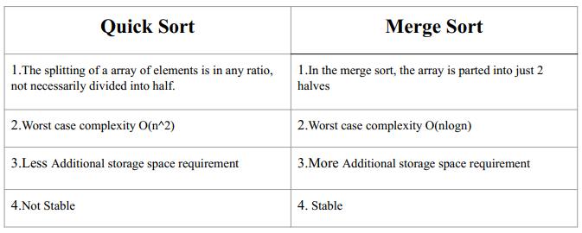
13. Merge Sort VS Quick Sort

14.

